|  |  |  |  |
| --- | --- | --- | --- |
| **F:\Learning bugs\Foundation Subjects\Dolly the Fly - Science.jpgLyng Primary School Knowledge Organiser** | | | |
| **Topic: Science** | **Animal including humans: lifecycles and health**  **What are the stages in life for animals and humans?** | Year 2 | Spring Term |

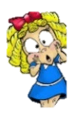

**Key knowledge**

|  |  |
| --- | --- |
| **What Goldilocks and Step On words will I use?** | |
| **Spelling** | **Definition** |
| Health | How the body feels. |
| Hygiene | Keeping things clean. |
| Life cycle | The stages an animal goes through to become an adult. |
| Offspring | Young animals or plants that produced by parents. |
| Survive | To continue to live. |

By the end of the unit, to know:

* That baby, toddler, child, teenager and adult are human life cycle stages.
* There are differences in the life cycles of different animals.
* Humans grow as they age.
* The basic survival needs of animals are air, water and food.
* Personal hygiene prevents the spread of germs.
* Washing our hands and changing our clothes are ways to keep clean.
* Exercise can improve performance and well-being.
* The five food groups are carbohydrates, fruits and vegetables, dairy and alternatives, protein and oils and spreads.
* Humans require a balanced diet to stay healthy.

**Notable Scientist:**

**Charles Darwin** – English scientist known for his contributions to evolutionary biology.

|  |
| --- |
| **Key questions - sequence of learning** |
| * What are the different stages of the human lifecycle? * Which offspring come from which animal? * How do we measure growth in humans? * What are the basic needs for humans and animals? * Why is it important to exercise and have good personal hygiene? * What do we need in a meal to make a balanced diet?   We will conduct an investigation to find out:  **If the older you are the taller you are?** |

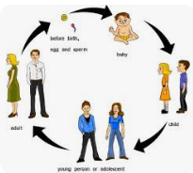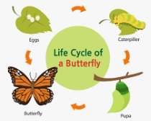

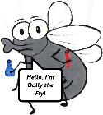

**What will I know by the end of the unit?**

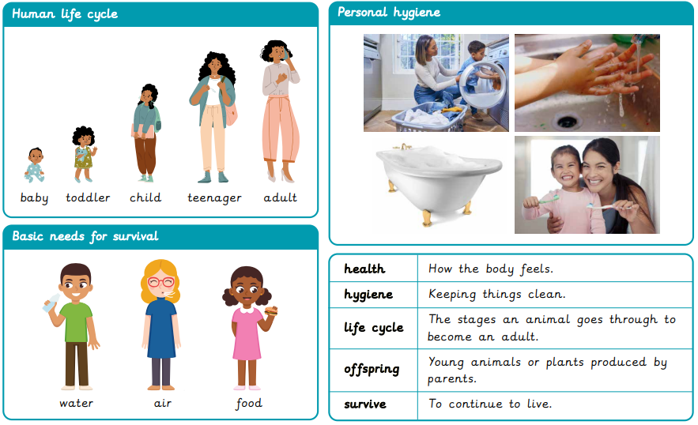

|  |  |  |  |
| --- | --- | --- | --- |
| **F:\Learning bugs\Foundation Subjects\Dolly the Fly - Science.jpgLyng Primary School Knowledge Organiser** | | | |
| **Topic: Science** | **Animal including humans: lifecycles and health**  **What are the stages in life for animals and humans?** | Year 2  Materials | Spring Term |

|  |  |  |  |
| --- | --- | --- | --- |
| 1. Tick all the things that all animals need to survive | **S** | | **E** |
| Water |  |  | |
| Exercise |  |  | |
| Air |  |  | |
| Food |  |  | |

|  |  |  |
| --- | --- | --- |
| 5. Which one does a human not need to survive? | **S** | **E** |
| Water |  |  |
| Sweets |  |  |
| Food |  |  |

|  |  |  |
| --- | --- | --- |
| 4. Place these in order of how they happen in the life cycle of a human: | **S** | **E** |
| Elderly |  |  |
| Toddler |  |  |
| Adult |  |  |

|  |  |  |
| --- | --- | --- |
| 2. How can humans keep healthy? | **S** | **E** |
| Look after animals |  |  |
| Exercise |  |  |
| Balanced Diet |  |  |
| Medicine when given by a doctor or nurse |  |  |

|  |  |  |
| --- | --- | --- |
| 3. The word offspring means…. | **S** | **E** |
| A person’s or plant’s young |  |  |
| A form of gymnastics |  |  |
| To go on and then off |  |  |
| A season of the year |  |  |

|  |  |  |
| --- | --- | --- |
| 6. Which one is not hygienic? | **S** | **E** |
| Washing your hands before eating. |  |  |
| Sneezing into the crease of your arm. |  |  |
| Not washing your hands after going to the toilet. |  |  |
| Binning a tissue once it has been used. |  |  |